10 DAYS YACHT AND CRUISE WORKSHOP FETHIYE AND ANTALYA FAM TOUR

Tour Start Date: 19 October 2021, Tuesday

Tour Route: Istanbul - Dalaman – Fethiye-Antalya – Istanbul

The conference will take place on 21 October,2021. The B2B meetings among with hoteliers & hosted buyers will take place on 22 October, 2021.
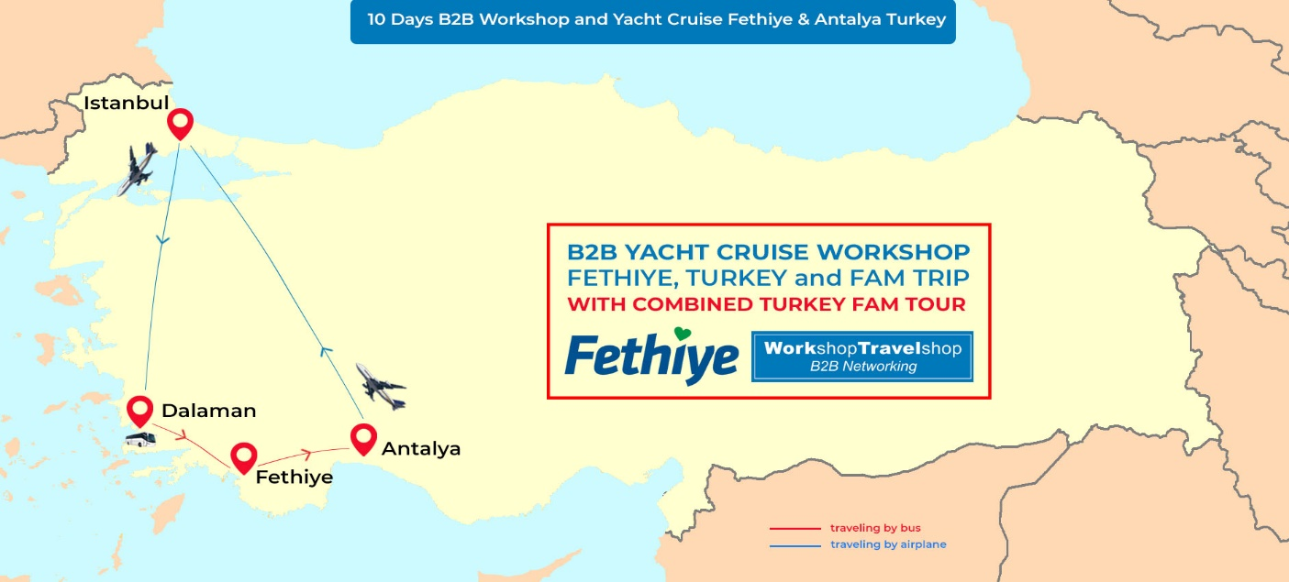

Summary
Fethiye, located perfectly between the Aegean and Mediterranean, has Crystal Clear Turquoise waters and globally famous for its beautiful beaches. Besides, Fethiye is a major center with its deep canyons, valleys, Water sports and Paragliding activities. One of the most important function to Fethiye is the special wooden boats and yacht cruise between Aegean and Mediterranean as well towards the Greek Islands. This extraordinarily beautiful place will be hosting us for B2B Workshop event along with yacht Cruises planned. This unique and superb region is especially good for the ones planning on Weddings and M.I.C.E organizations, Sea, sand and sun, adventure, yacht Cruise, family holidays, honeymoons, as a luxury tourism destination. We are sure with this Fam Trip; you will have a great opportunity with a Perfect destination to promote. There is no long Coach rides and we include domestic flights from Istanbul to Dalaman Airport.

Day 1 - Istanbul - Arrival Day – (19 October 2021, Tuesday)
Dinner Included
Welcome to Turkey! Meet at the airport, transfer to your hotel.
You will be given your room key and the rest of the day is yours to explore Istanbul. Dinner and Overnight in Istanbul.
Please note that; Our arrival airport transfer services will be available between 07:00am to 22:00pm from Istanbul Airport.

Dinner and overnight at Pullman Hotel.

Day 2 - Istanbul City Tour / Welcome Dinner (20 October 2021, Wednesday)
Breakfast, Lunch, Dinner Included

09:00 Depart for Istanbul City Tour

Visit ST. Sophia. This ancient basilica, built by Constantine the Great in the 4th century and reconstructed by Justinian in the 6th century, is one of the architectural marvels of all time. SULTANAHMET IMPERIAL MOSQUE Across from St. Sophia built in the 16th century by the architect Mehmet, is known as the BLUE MOSQUE because of its magnificent interior decoration of blue Iznik tiles. HIPPODROME Ancient Hippodrome, the scene of chariot races, with the three monuments; the Obelisk of Theodosius, the bronze Serpentine Column and the Column of Constantine.

12:30 – 13:30 Lunch Break

After the lunch, we will visit the unique Leather Factory’s leather fashion show.
16:00 ASİL EFENDİ SPICE BAZAAR visit
The air here is filled with the enticing aromas of cinnamon, caraway, saffron, mint, thyme and every other conceivable herb and spice.

Welcome Dinner outside at the Lionel Hotel Istanbul from 20:00 to 22:00 .
18.00 pick up from Pullman Hotel to Lionel Hotel.
22.00 depart for Pullman Hotel.

Overnight at Pullman Hotel.

Day 3: Destination Wedding (IADWP) Guest Speakers / Dinner at Bosphorus Cruise (21 October 2021, Thursday)
(Breakfast, Lunch, Coffee Breaks, Dinner Included)

From 07:00 to 09:00 Breakfast
Registration Process from 09:00 to 10:00
10:00 Opening Ceremony
10:30 to 12:30 Guest Speaker Session
12:30 to 13:00 Lunch Break
13:30 to 15:30 Guest Speaker Session Resume

15:30 to 15:45 Coffee Break
15:45 to 17:00 Final Speaker Session
18:30 depart for dinner
19:30 – 22:30 dinner at Bosphorus Cruise
Overnight at Pullman Hotel.

Day 4: B2B Workshop and Yacht Cruise Event (22 October 2021, Friday)
(Breakfast, Lunch, Coffee Breaks, Gala Dinner Included)
From 07:00 to 09:30 Breakfast
10:00 - 11.30 Destination Weddings and Romance Industry Professionals B2B Meetings
11:30 to 11:45 Coffee Break
11:45 to 12:45 B2B Meetings Resumed
12:45 to 14:00 Lunch Break
14:00 to 15:30 Continue with B2B Meetings
15:30 to 15:45 Coffee Break
15:45 to 17:30 continue with B2B Meetings
19:00 – 23:30 Award Ceremony & Gala Dinner at Pullman Hotel
Overnight at Pullman Hotel

Day 5 - Early Flight from Istanbul to Dalaman and Fethiye SUV Safari – Saklikent
(23 October 2021, Saturday)
Breakfast, Lunch, Dinner Included
06:30 Early check out from the hotel and transfer to the airport for your Dalaman flight

After arrival head to Fethiye where all jeeps depart for an enjoyable day. First stop is the archaeological site of Tlos, situated on a steep hill and therefore unfortunately difficult to reach. We can see an Ottoman Castle on the top, Lycian rock graves and a Roman theatre. Afterwards we visit the trout farm of Yakapark and the hidden canyon of Saklikent. You can wade through this wonderful gorge in fresh jade-colored spring water, slowly climbing to a waterfall.
12:30 – 13:30 Lunch Break
After lunch, we drive to Xanthos, the capital of the Lycians, and to Patara, the longest sand beach of Turkey where we dive in the turquoise sea!

18:00 End of the tour and drive to your hotel.
Overnight in Ocean Blue High Class Hotel.

Day 6 – Fethiye City Tour and Yacht Cruise to Cleopatra’s Baths – Bedri Rahmi Bay – Tersane Bay (24 October 2021, Sunday)
Breakfast, Lunch, Dinner Included
09:00 Depart for Fethiye City Tour
12:00 Fethiye Yacht Cruise, visit Cleopatra's Baths (Hamam Bay). Enjoy a swim in the ancient ruins of these Roman Baths. Then cruise to Sarsala Bay, a striking pine-surrounded bay. It is also a convenient starting point for a 45-minute hike to ancient Lissa, notable mostly for inscribed walls dating from the 3rd Century BC rule of two of Cleopatra's Ptolemy forebears. Bedri Rahmi is our next stop, named after one of the first ˜Blue Cruisers' who painted here in 1973 a fish on the rocks. Jump in the water or explore the island.
Dinner and overnight at Yacht.

Day 7 – Fethiye Yassica Islands – Gocek Islands (25 October 2021, Monday)
Breakfast, Lunch, Dinner Included

10.00 Continue cruising, to the Yassica Islands. These tiny islands do not have individual names. They are so small that no one has named them. The biggest one has a sandy beach and there is a small pool cape off the lagoon. We will then cruise to the tranquil area of Gocek Islands where we can swim, snorkel or just soak up some sun and enjoy the beautiful surroundings. A last swim at Red Island and overnight in Samanlik Bay.
Dinner and overnight at Yacht.

Day 8 - Fethiye to Antalya – (26 October 2021, Tuesday)
Breakfast, Lunch , Dinner Included
09:00 Depart for Dalaman Airport for your flight back to Istanbul ( For the people who has flight to Istanbul )

10:00 Check out from the hotel and transfer to Antalya
13:00 Transfer to your hotel in Antalya
Dinner and overnight in Miracle Hotel
Day 9 - Antalya Old City Tour and Waterfalls - (27 October 2021, Wednesday)
Breakfast, Lunch , Dinner Included
08:30 Depart from the hotel for Antalya Old City Tour
Kaleiçi Marina, Clock Tower, Hadrian's Gate, Broken Minaret, Hıdırlık Tower: Kaleici is a small historic part of Antalyas modern city, also known as the Old City of Antalya. In history it was once the sprawling modern Roman town, then the Byzantine Empire, then Seljuks, and finally the Ottoman Turkish town. The Hadrian's Gate (or Hadrianus Gate or The Three Gates is a triumphal arch which was built in the name of the Roman emperor Hadrian. Antalya's broken wonder is the Broken Minaret of the Korkut Mosque, which itself was built originally as a Roman temple in the 2nd century AD, and thus did not have a minaret at all. Hıdırlık Tower is a landmark tower of tawny stone in Antalya, Turkey, where Kaleiçi meets Karaalioglu Park. It is believed to be built in Hellenistic era on a square plan and later turned into circular tower in 2nd century AD and was either used as a fortification or a lighthouse in the past.
12:30 – 13:30 Lunch
Then continue with Duden waterfalls. All the streams of the region aim at finding their way into the Mediterranean and they pour down the slopes of the Taurus, sometimes overland sometimes underground and reaching their destination, result in lovely waterfalls, of which there are more than twenty.
Dinner and overnight in Miracle Hotel
Day 10 - Antalya to Istanbul - End of Tour - (28 October 2021, Thursday)
Depart for Antalya Airport for your flight back to Istanbul

We hope you have a memorable time in Turkey and we look forward to seeing you in the future on another B2B WorkShopTravelShop organisation. Have a safe trip back home and thank you for choosing WorkShopTravelShop.

INCLUDES
- Airport transfer services mentioned in the tour itinenary
- Domestic flights from Istanbul to Dalaman Airport
- Domestic flights from Antalya Airport to Istanbul
- 4 Night hotel accommodation in Istanbul
- 1 Nights’ hotel accommodation in Fethiye
- 2 Nights at Yacht Cruise
- 2 Nights’ all-inclusive hotel accommodation in Antalya
- 9 Open Buffet Breakfasts
- 8 Lunches
- 8 Dinners
- 1 Gala Dinner
- Guided Istanbul City Tour
- Guided Fethiye SUV Safari – Saklikent
- 12 Island Yacht Cruise (Cleopatra’s Baths – Bedri Rahmi Bay – Tersane Bay – Sarsala, Yassica & Gocek Islands)
- Guided Antalya Old City Tour and Waterfalls
- B2B Workshop Networking Event
- Professional English speaking tour guides

EXCLUDES
- International flights
- Insurance of all types
- Items of a personal nature such as alcoholic beverages, cold drinks, laundry
- Any others expenses which are not mentioned within the included section

TERMS and CONDITIONS
- Abide by the Workshop calendar.
- Act in line with departure times.
- Minimum 30 pre-appointments taken per Hosted Buyers that to be signed by the appointee.
- Hosted Buyers not to promote their own “incoming” services to the participants and if detected, would be disqualified and charged for the full fee.
- Accommodations assigned should be taken into consideration and may not be altered during the trip in Turkey.
- Flight details to be registered on the system and we are not responsible of transfer services for the ones that are not registered.
- Please check your appointments and business cards.
- Only registered parties can enroll in Hosted Buyer Program. No one else can be invited without prior permission. Only the officially invited ones may stay through the event.
- We are expecting all Hosted Buyers to pay necessary attention and care for this event.
- You can ask for help of our team to be located in Hosted Buyer area throughout the event.
- Accepted invitations to Hosted Buyers are non-transferable. In case, where the Hosted Buyer is no longer able to attend, another attendee from their organization may replace with a renewed application, placed 45 days prior.
- Hosted Buyers who do not inform the Organizer of their cancellation and do not participate in the program, will be deemed a No-Show at 100%.
- All cancellations are subject to a written request and to be confirmed in return
- Tours only cancellation policy: Fully refundable in any cases and credit towards to the next event under Force Majeure conditions till 3 weeks event start date. 3 Weeks before 100% credit, 2 Weeks before Non-refundable
- P.S Whether you have altered the dates and/or any Event and Fam Trip purchases made by you from our product selection, you may use the credit by the rates as indicated above towards your purchases for the duration of 1 years on Workshop TravelShop events.

Pullman Hotel Address: Yenibosna Merkez, Mahallesi, 1. Asena Sk. No:15, 34295 Bahçelievler/İstanbul Phn: (0212) 411 10 00

Ocean Blue High Class Hotel Address: Ata Caddesi No:6 Hisarönü – Ölüdeniz Mevkii / Fethiye Phn: +90 252 616 7646 / +90 252 616 8207

Miracle Hotel Address: Güzeloba, Yaşar Sobutay Bulvarı No:34, 07230 Muratpaşa/Antalya
Phn: (0242) 352 21 21

